Code

//To utilize the various string functions available in the c library

#include<stdio.h>

#include<string.h>

void main()

{

int l;

char str1[100],str2[100],str3,str4[50],a[]="computer", b[]="MECHANICAL";

printf("enter string 1");

gets(str1);

printf("enter string 2");

gets(str2);

l=strlen(str1);

printf("length of string 1=%d\n",l); //prints the length of string

strcat(str1,str2);

printf("strcat=%s\n",str1); //concatenates str2 in str1

strcpy(str1,str2);

printf("strcpy=%s\n",str1); //copies the string str2 to str1

strstr(str1,str2);

printf("strstr=%s\n",str1); //prints the substring based on str2

if(strcmp(str1,str2)==0) //compares if the strings are the same

printf("strings are same\n");

else printf("strings are not same");

printf("enter element to be searched");

scanf("%c",&str3);

printf("strchr=%s",strchr(str1,str3)); //prints the substring by comparing the character constant str3

//uses strupr and strlwr

printf("\nString a is %s",a);

printf("\nString b is %s",b);

printf("\n\nString a in uppercase is %s",strupr(a));

printf("\n\nString b in lowercase is %s",strlwr(b));

printf("\nEnter the string to be reversed \n");

scanf("%s",&str4);

printf("The reversed string is %s \n",strrev(str4)); //prints the string in reverse

}

Output:

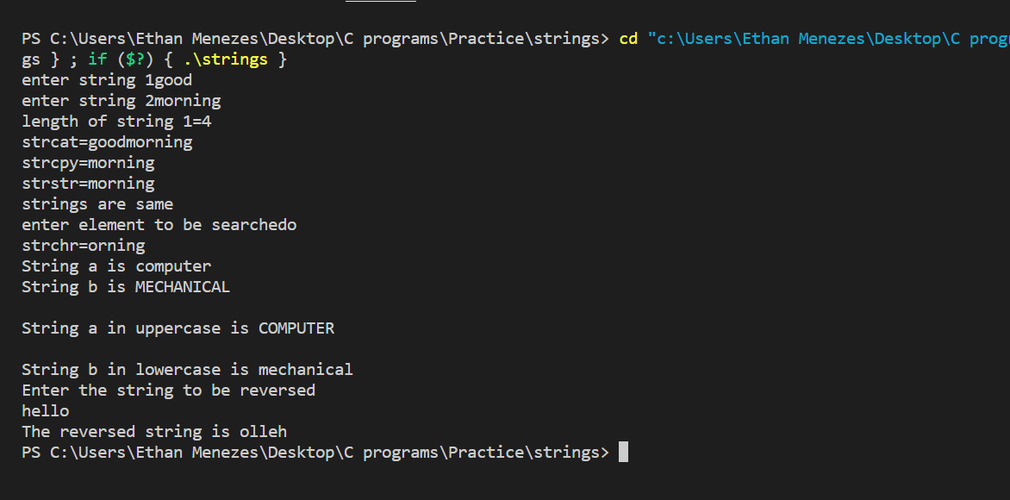

Conclusion: C program for string inbuilt functions was implemented successfully.